**Project progress this quarter**

The work-plan of LIZARD has been defined as the following diagram:

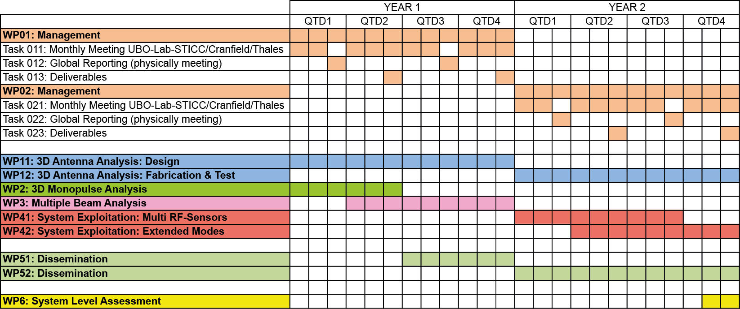

~~The work of this quarter concerns WP1, WP2, WP3 and WP4:~~

* **~~WP1: Antenna Co-Design~~**

*~~Task 1.4: Whole antenna co-design~~*~~.~~

~~Taking into account the measurements done on the basic prototypes, new antennas have been designed by the Lab-STICC in order to show the technological capability of the additive technologies (plastic and metal).~~

* **~~WP2: Technological Process Analysis~~**

*~~Task 2.2: Advanced Molding injection~~*~~.~~

~~Pre-analysis of overmolding technology has been launch with AV-Plastics. A 3D shape has been selected to show the technological capability of this technique to realise multi-layer antennas. Multilayer antenna will allow the simplification of the feeding network and then will present better performances.~~

*~~Task 2.3: Advanced 3D printing~~*~~.~~

~~3D-Alchemy is currently finishing the state of the art of 3D plastic and hydrid 3D printing. Several meeting have been done with the Lab-STICC in order to focus on antenna applications. The future trends of 3D printing is also analysed in this state of the art. In addition, prototyping has been done in collaboration with the Lab-STICC to test the capabilities of the 3D plastic printing using the available techniques.~~

~~With the same objectives, 3T RPD is doing the state of the art of the 3D Metal Printing. Several meetings have been also done to well focus the report on antenna applications.~~

* **~~WP3: Fabrication and Tests~~**

*~~Task 3.2: Basic Antenna Prototype Fabrication~~*~~.~~

~~Post-processing techniques are currently studied in collaboration with 3TRPD to provide a good surface finishing and to improve the component performances. Prototypes have been launched to test the blasting and extrude hone techniques on the inner surface of waveguides. Other prototypes are currently on fabrication to test the silver metal plating in order to reduce the losses in the case of the Titanium 3D printing.~~

~~Basic prototypes have been fabricated by 3D Alchemy in 3D plastic printing in order to test the 3D selective metallisation. These samples will also allow us to highlight a new concept of non-homogenous substrate thickness to simplify the feeding network of the antenna array.~~

*~~Task 3.3: Advanced Prototype Fabrication~~*~~.~~

~~For the 3D metal printing:~~

~~Slotted antenna waveguides of various forms has been fabricated. The material used is the smooth aluminium. More advanced antenna arrays are under discussion between Lab-STICC and 3T RPD and are expected to be launched at the end of july.~~

~~For the 3d plastic printing:~~

~~Designs using curved substrates have been sent for prototyping in order to test curved antenna arrays.~~

*~~Task 3.4: Metallization & Integration Processes & Antenna Measurements~~*~~.~~

~~For the 3D metal printing, the first slotted waveguide antenna prototypes have been measured (return loss) and showed promising results.~~

~~First metallization tests have been done on the plastic samples and the measurement is expected to be done in September.~~

* **~~WP4: Dissemination~~**

*~~Task 4.2: Conference~~*~~. Participation at a French Conference (JNM 2015, 2-5 june, Bordeaux).~~

~~To conclude, the project is on target and on schedule.~~

**~~Top project highlights this quarter~~**

* ~~According to the promising results obtained previously for waveguides, other prototypes have been designed (waveguides, slotted waveguide antenna arrays) and some of them have been already fabricated.~~
* ~~New conformal arrays have been designed and are currently in the fabrication step using 3D plastic printing.~~

**~~Forecast Progress next quarter~~**

* ~~To continue the work on the technological processes (WP2). The pre-analysis concerning over-molding will be finished at the end of july and the fabrication will be then launched.~~
* ~~To continue the WP3. Fabrication of the last 3D metal prototypes (slotted waveguide arrays with conformal shape). 3D selective metallization on the prototype realized by 3D plastic printing (transmission lines, antenna element and antenna arrays).~~
* ~~Measurement of the new basic and advanced antenna prototypes~~